Lesson 4 Demo 8: Remote Triggering Parameterized Builds

This section will guide you to:

* Trigger parameterized builds in Jenkins remotely

This lab has two sub-sections, namely:

1. Configuring a parameterized build in Jenkins

2. Triggering a parameterized build remotely

**Step 1:** Configuring a parameterized build in Jenkins

* Go to Jenkins **dashboard**.
* Navigate to **Manage Jenkins**→ **Manage Plugins**→ **Available.**
* Search for Build with Parameters Plugin and click on **install without restart**.
* From the Jenkins **Dashboard**, click on ***New Item***.
* Enter a **name** for your build job.
* Select ***Freestyle project***as the build job type.

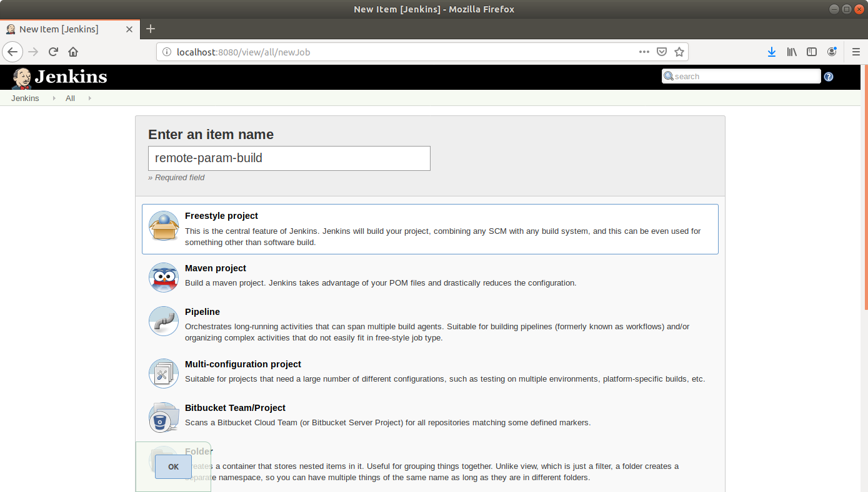

* Click **OK**.
* On the configuration page, select the checkbox next to text that states,***This project is parameterized*.**
* Click on the ***Add parameter*** button that appears.

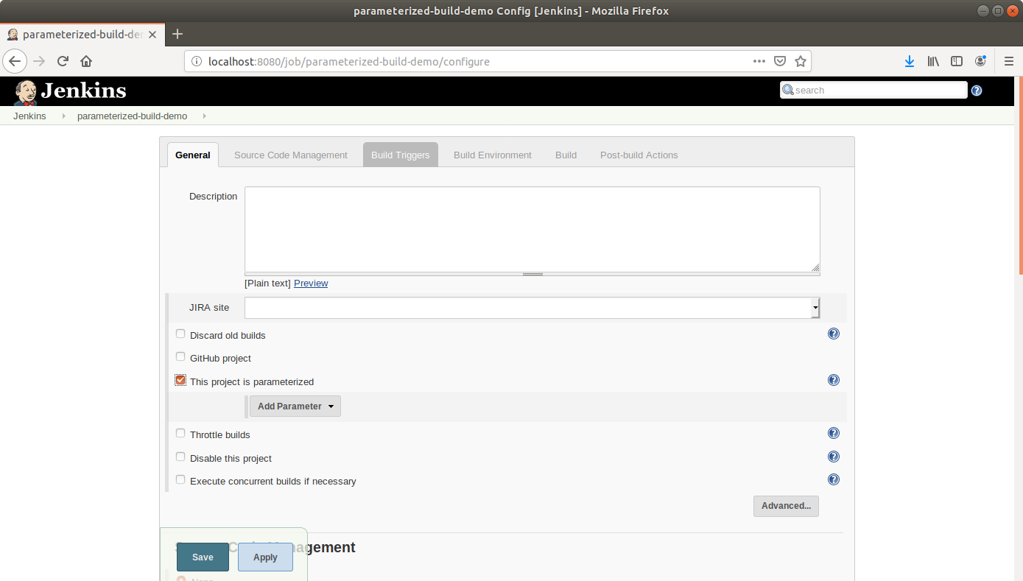

* From the drop-down menu that appears, select ***String parameter***.
* Name the parameter ***my_param***, and enter the ***Default Value.*** *(Ex: Hi)*

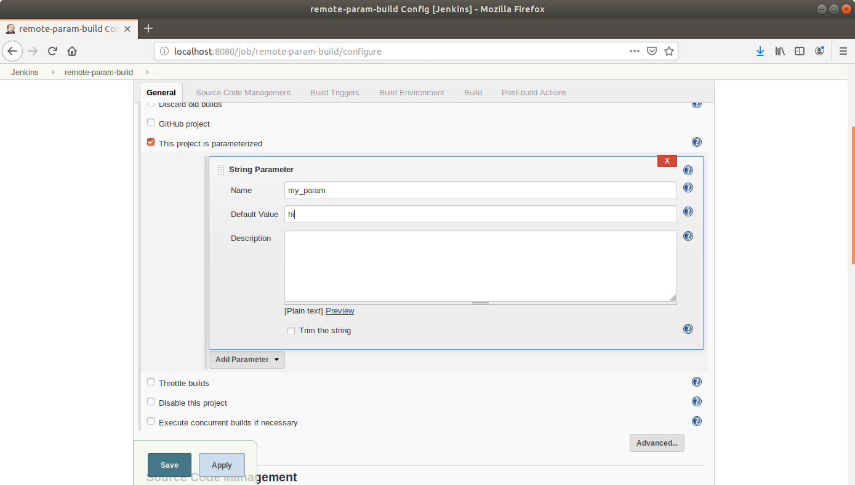

* Under the Build Triggers section select **Trigger builds remotely** and type **Sam** as the token value.

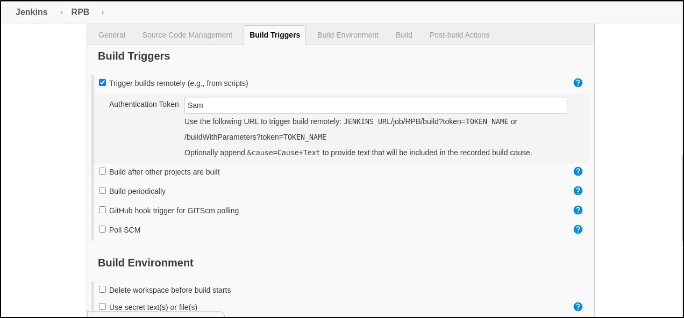

* Scroll down to the***Build*** section and click on ***Add build step***.
* Select***Execute Shell Command***from the drop down that appears.

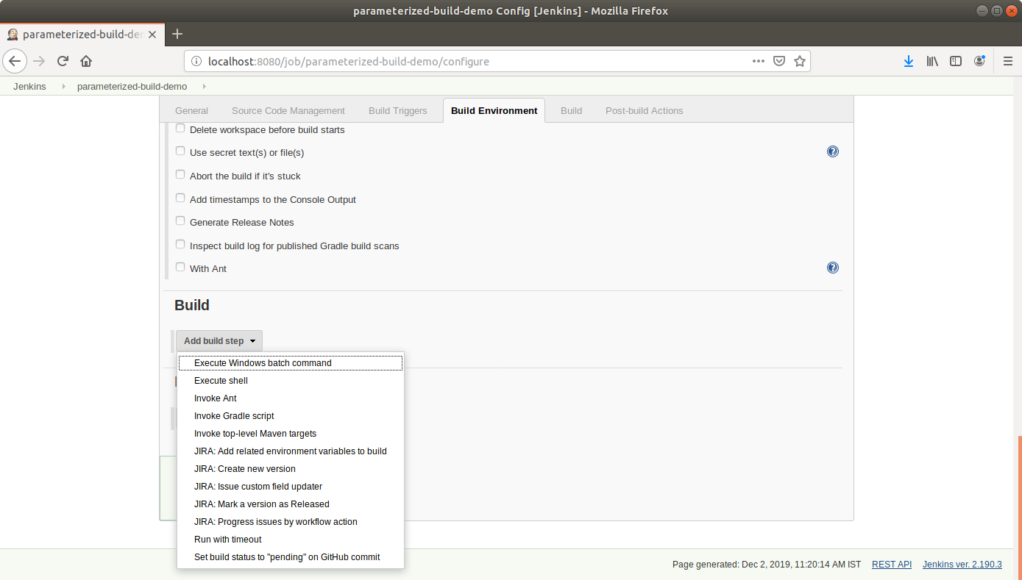

* In the text input area that appears, enter the following text:

**echo $my_param**

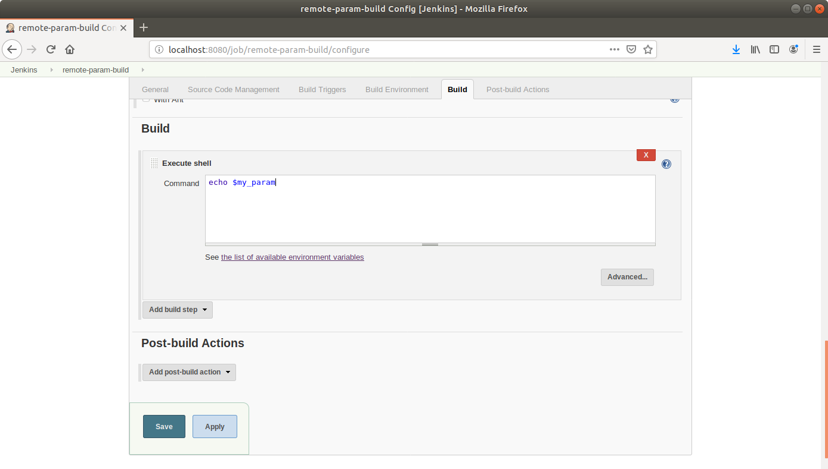

* Click **Save**.

**Step 2:** Triggering a parameterized build remotely

* Copy the **url** to the job from the project window.

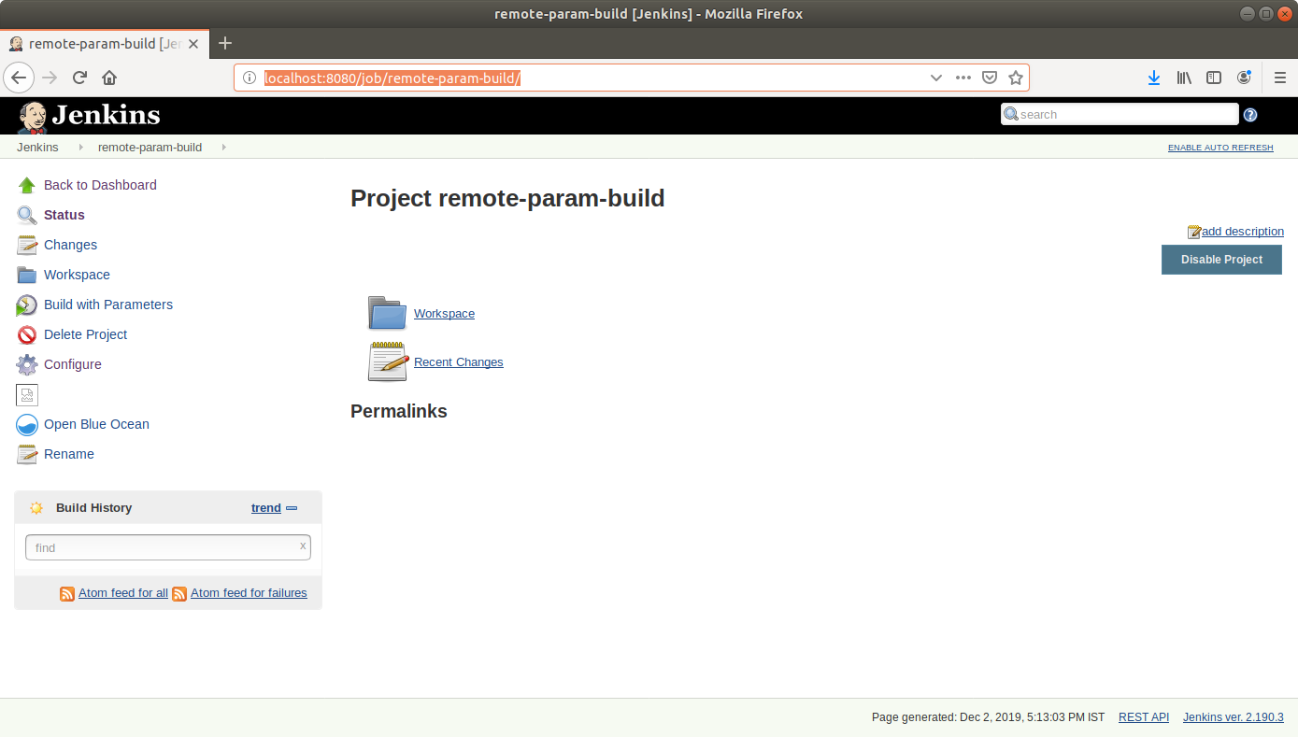

* Open the terminal.
* Suffix the parameter and its value to the url copied in the previous step and send a *GET* request using *Curl*.

**curl -X GET <YourJenkinsJobUrl>/buildWithParameters?token=Sam**

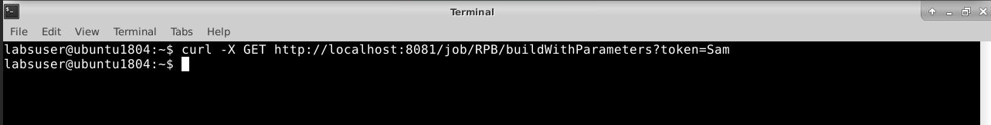

* Open the **job** in the Jenkins UI.
* Click on the ***Build History***to view the build results.
* Click on the ***Console Output*** to view the build logs.
* The parameter value will be displayed in the console output.

